Конкурсно-розважальна програма

***Halloween***

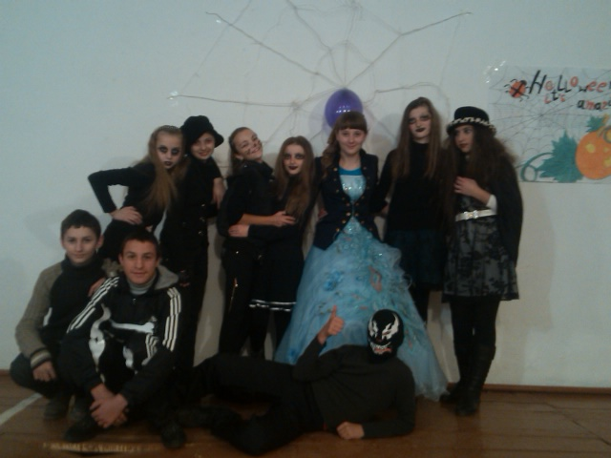

***Мета:*** 1) освітня: поглибити знання учнів про свята і традиції країни, мова якої вивчається, автоматизувати навички діалогічного та монологічного мовлення;

2) розвиваюча: розвивати естетичне сприймання дійсності та культуру спілкування, уяву учнів в умовах драматизації;

3) виховна: виховувати повагу до традицій народу Англії, інтересу до вивчення англійської мови.

*In the left corner of the stage there is a small house. There is a ladder with a spider web on it, the spider is sleeping. On the background the stars are shining. There is a calendar on the wall. Soft music is heard wakes up and looks at the calendar.*

**Spider:** Oh, it is October 31. It’s our day today! Where is main Witch? Hasn’t she woken up yet? I should go and wake her up at once. But I must do morning exercises first! *(He begins to sing a rap song):*

I am a spider,

A spider am I.

Don’t ever touch me

Because you will cry.

I am a spider,

My colour is black,

And that’s a web

Behind my back.

I am a spider,

My web is light,

It can easily

Catch a fly.

I am a spider,

Step out of my way,

I never say “die!”

But say “OK!”

**Main Witch***(looking out of the window):*What’s the matter? Who dares to wake me up? It is you, mynaughty little Spider? Why are you making so much noise?

**Spider:**Yes, it’s me! Look at the calendar! Today is October 31. It is our great holiday- Halloween!

**Main Witch:**At last I have woken up!I have been sleeping for a long time. And I must confess it is not a funny thing to sleep all the year long! It is our holiday today-our time has come at last! Oh, I should inform all my assistants. They will arrange everything for me and we shall have a cool time! *(takes the telephone)*Hello! Hello,

my darlings! Have you woken up already? The day of Halloween has come! I am waiting for you just now!

*(The announcement is heard).*

Attention! Attention!

General Assembly of all evil spirits is to be held in the hall in a minute!

*(The announcement may be repeated twice while pupils gather in the hall).*

**Main Witch:** My dear Spider, have you seen my sister Madge? Oh, here she is! (*Madge appears and runs ton Main Witch).*

**Madge:** I am here! Hope, I am not late? Hello, my dear! I am very glad to see you! How are you?

**Main Witch:** I am awfully bad! And what about you?

**Madge:** Just the same: I am very bad, too. Oh, how many guests! How are you?

(*Guests are coming saying: “Bad evening! We are bad , too!”)*

So, if all of us are very bad and angry today, let us sing our song!

We are angry today,

Please, step out of the way

`Course the holiday`s coming,

We are angry today!

(*On the melody “Happy Birthday”)*

**Main Witch:** Is everybody here? So, I have the honour to declare our General assembly open!

**Twinkle, twinkle, little star**

Twinkle, twinkle, little star.

How I wonder what you are!

Up above the world so high,

Like a diamond in the sky.

When the blazing sun is gone,

When he nothing shines upon,

Then you show your little light,

Twinkle, twinkle, all the night!

Ann and Jane Tailor

**Witch with a Cauldron:**

In the cauldron boil and bake

Eye of newt and toe of frog,

Wool of bat, and tongue of dog,

Adder`s fork, and blind-worms`s sting,

Lizard`s leg, and owlet`s wing,

For a charm of powerful trouble

Like a hell-broth boil and bubble,

Double, double toil and trouble,

Fire burn and cauldron bubble.

**Main Witch:**We have some new guests now. Here they are coming!

*(All kinds of different strange creatures such as witches, ghosts, dwarfs come into the hall with the words):*

Ghosts and witches

Can be seen

Trick-or-treat

Trick-or-treat

Give us something

Good to eat!

The sky is blue

The sky is green

Have you got a penny?

For Halloween!

For Halloween!

For Halloween!

*(All are dancing “Looby-Loo”).*

**Madge:**Oh, I see a black cat among our guests. Let us invite him to our party.

**Black Cat:**I am a black cat with an arched back. Once I was a human being, but I was punished for my evil deeds. Thus I have become a black cat. But today I came here with my friends – little black kittens. Here they are!

Kittens are furry,

Kittens are puny,

They lap at milk in a shallow dish,

They lick their whiskers and dream of fish.

*(Kittens dance).*

**Main Witch:** Do you know that black cats were the partners of witches? Many people were afraid of cats. Some thought cats were the spirits of the dead. Others believed that witches changed themselves into cats. If people met a cat they asked: “Is this really a cat? Or is this a witch changed into a cat?” *(Ghosts appear on the stage).*

**Ghost 1:** A flash of white in the darkness,

Who-oo-ooo?

Hoots the owl on the post.

**Ghost 2:** A creak and a groan,

A squeak and a moan,

Ooo-oo-ooo!

**Ghost 3:** Cames the howl-

It’s a ghost!

*(Ghosts dance and sing).*

I am a tiny ghost,

A ghost, a ghost!

I like to frighten people,

The most, the most

I used to fly at night,

At night, at night

Because I’m so light,

And white, and white!

**Wicked Witch:** I am a wicked witch, who made a beautiful princess sleep for hundred years. Do you remember?

In a castle long ago

A royal babe was born.

And all the land did celebrate

That happy birthday morn.

But then a wicked witch appeared

And warned the princess dear:

“Beware the rose, for when it pricks,

You’ll sleep a hundred years!”

**Fairy:** I am a very kind fairy. I shall help the princess to wake up. Do you remember?

“This evil spell”, a fairy cried,

“Just might not have to be!

A handsome prince

-If brave and true-

Can kiss and set her free!”

**Vampire:** Did you recognize me? Yes, I am a vampire… Do you know that vampires are supposed to be dead men who have come back to life? At night, after sunset, we leave our graves to look for human blood. We return to our graves before dawn.

**Skeletons:** We are skeletons. We came here to frighten you. Many people cannot stand our strange jokes. Are you afraid of us?

*(They sing and dance).*

We are skeletons,

Skeletons we are.

Aren’t you afraid of us?

Ah-ha-ha!

Rattling our bones

For the whole night.

We’ll disappear

At dawn light.

*(Jack-o’-Lantern appears).*

**Madge:** What a surprise! Who are you? You look so funny!

**Jack-o’-Lantern:** I am Jack-o’-Lantern. Once my name was Jack when I was a man. But I was so mean that I could enter neither heaven nor hell. I had to walk the earth forever since then. And this is my head-you take a large pumpkin and cut off a piece from the top. Then you cut out the eyes, nose, and mouth and put a candle inside the lantern. Look, you can see the candlelight through the eyes, nose, and mouth.

I’m Jack-o’-Lantern with a great big green,

I’m Jack-o’-Lantern with a candle in.

Poof! Goes the wind and out goes the light,

Away fly the witches on Halloween night!

By day the bat is cousin to the mouse,

He likes the attic of an aging house,

His fingers make a hat above his head,

His pulse is so slow we think him dead.

He loops in crazy figures half the night

Among the trees that face the corner light-

But when he brushes up against a screen,

We are afraid of what our eyes have seen:

For something is amiss or out of place

When mice with wings can wear a human face.

**Theodore Roethke**

**Main Witch:** Look! Here comes our last guest!

*(Pomona, the Queen of Apples appears).*

**Pomona:** Good evening! I am very glad to see you! My name is Pomona. I am the Apple Queen, Apples were once thought to be a link between men and gods. And you all know the English proverb- “An apple a day keeps the doctor away”. Every year people bring me apples and nuts, in this way they thank me a good harvest. I am very beautiful and kind.

(*Pomona comes into the hall and gives apples and nuts to everyone).*

**Madge:** Are you happy now? Let us sing and dance.

*The waltz “Halloween”is heard).*

Halloween! Halloween!

It`s a holiday!

So bright and gay,

So bright and gay-

It`s a holiday!

Halloween! Halloween!

Time has come

For all to play

It’s a holiday!

Halloween! Halloween!

It’s a holiday! So bright and gay,

So bright and gay-

It’s a holiday!

The weather is fine,

No clouds in the sky

And the heaven’s blue.

Witches are here,

Wizards appeared

With a smile to you!

**Main Witch:** Now let us have some fun. We shall play a very lovely game. You see a bowl of water. Here are some apples in it. You have to catch an apple with a fork. Try, please! OK! Very well! But first of all I am going to cover your eyes with a scarf.

**Madge:** I want you to play another game. This is a parcel. Stand in a circle and pass the parcel to the person next to you. There is music playing when you are doing this. When the music stops you take off one piece of paper. Then the music starts again. The person who takes the last piece of paper off is the winner. He or she wins the prize wrapped in paper.

**Main Witch:** Our Halloween party is coming to an end, and we hall it with a great costume parade. (*All participants come onto the stage in their costumes).*

**Main Witch:** Our meeting is over. Madge and me will be very glad to see you again next year on October 31.

